ASP.NET Core 8.0 Web API

5. Web API Hands on

1. Objective
To implement JWT Bearer authentication and authorization in an ASP.NET Core Web API, generate and validate JWT tokens, protect the Employee API using the Authorize attribute, test invalid and expired tokens, and implement role-based authorization.

2. Software / Tools Used
- Visual Studio
- ASP.NET Core Web API
- C#
- Postman
- JWT Bearer Authentication

3. Procedure and Implementation

3.1 JWT Bearer Authentication Configuration
The Microsoft.AspNetCore.Authentication.JwtBearer package was installed using NuGet Package Manager. JWT Bearer authentication was configured in Program.cs with a security key, issuer, audience, lifetime validation, and signing-key validation. Authentication middleware was added before authorization middleware.

3.2 JWT Token Generation
An AuthController was created with an anonymous GET endpoint to generate a JWT token. The token contains a role claim and UserId claim and is signed using HMAC SHA-256. The token was configured with an issuer, audience, and expiration time.
- Issuer: mySystem
- Audience: myUsers
- Role claim: Admin
- UserId claim: 1
- Token expiration: 10 minutes during the main test

3.3 Protecting Employee API
The EmployeeController was protected using the [Authorize] attribute. A valid JWT Bearer token is required to access the Employee API.

3.4 Testing Using Postman
The AuthController endpoint was called to generate a JWT token. The token was supplied as a Bearer token while accessing the Employee API. Requests were tested with missing, valid, modified, and expired tokens. Role-based authorization was also tested.

4. Test Cases and Results
Test Case | Expected Result | Observed Result
Request without JWT token | 401 Unauthorized | Successfully rejected
Request with valid JWT token | 200 OK with employee list | Successfully authorized
Modified JWT token | 401 Unauthorized | Successfully rejected
Expired JWT token | 401 Unauthorized | Successfully rejected
Unauthorized role (POC) | 401 Unauthorized | Successfully rejected
Authorized role (Admin) | 200 OK | Successfully authorized

5. Role-Based Authorization
Role-based authorization was tested by protecting the EmployeeController with the required roles. A token containing the POC role was rejected, while a token containing the Admin role was accepted. This confirmed that the API correctly enforces role-based access control.
[Authorize(Roles = "POC,Admin")]

6. Screenshots
Figure 1: Request without a JWT token returning 401 Unauthorized.
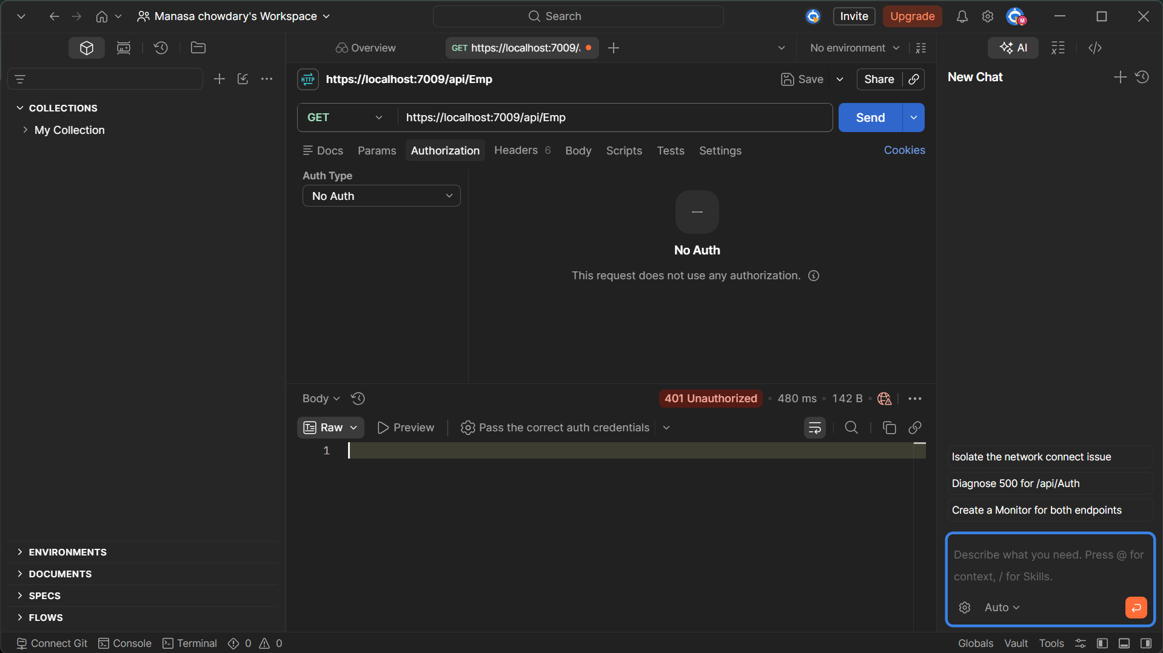
Figure 2: Request with a valid JWT Bearer token returning 200 OK and the employee list.
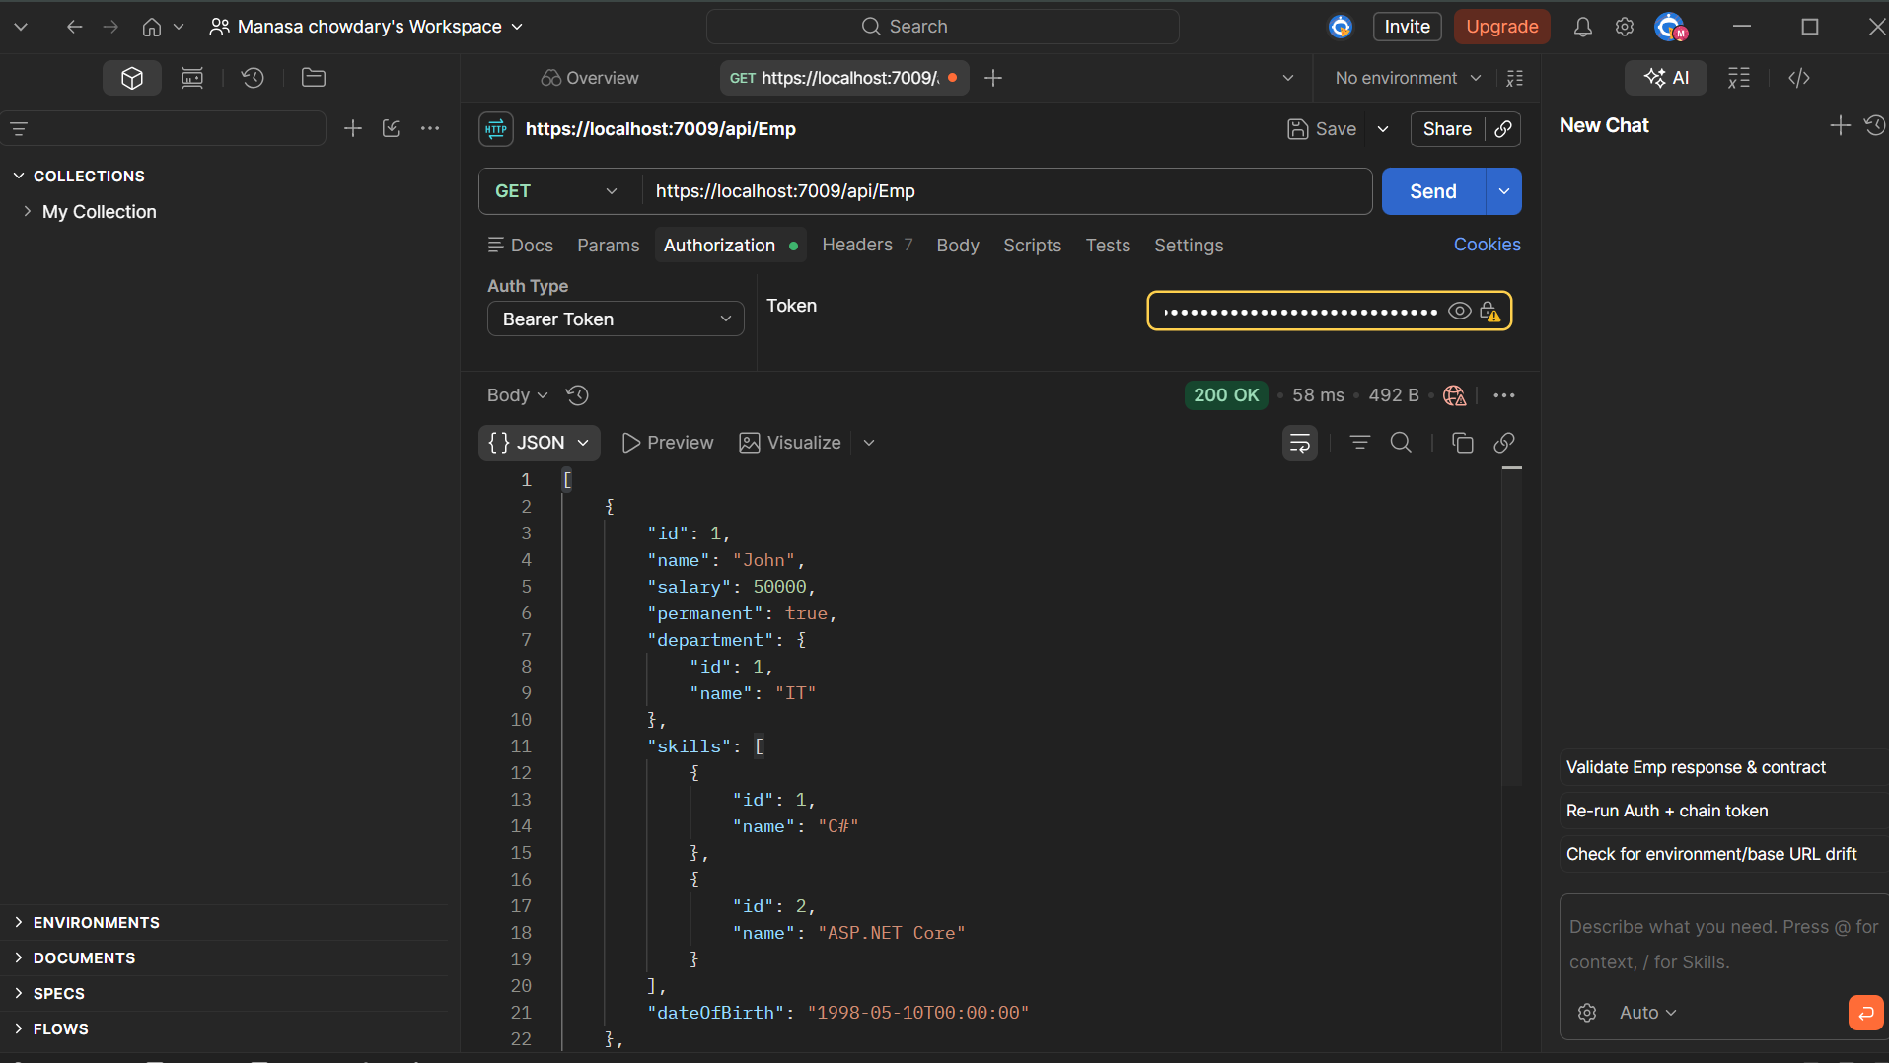
Figure 3: Modified JWT token returning 401 Unauthorized.
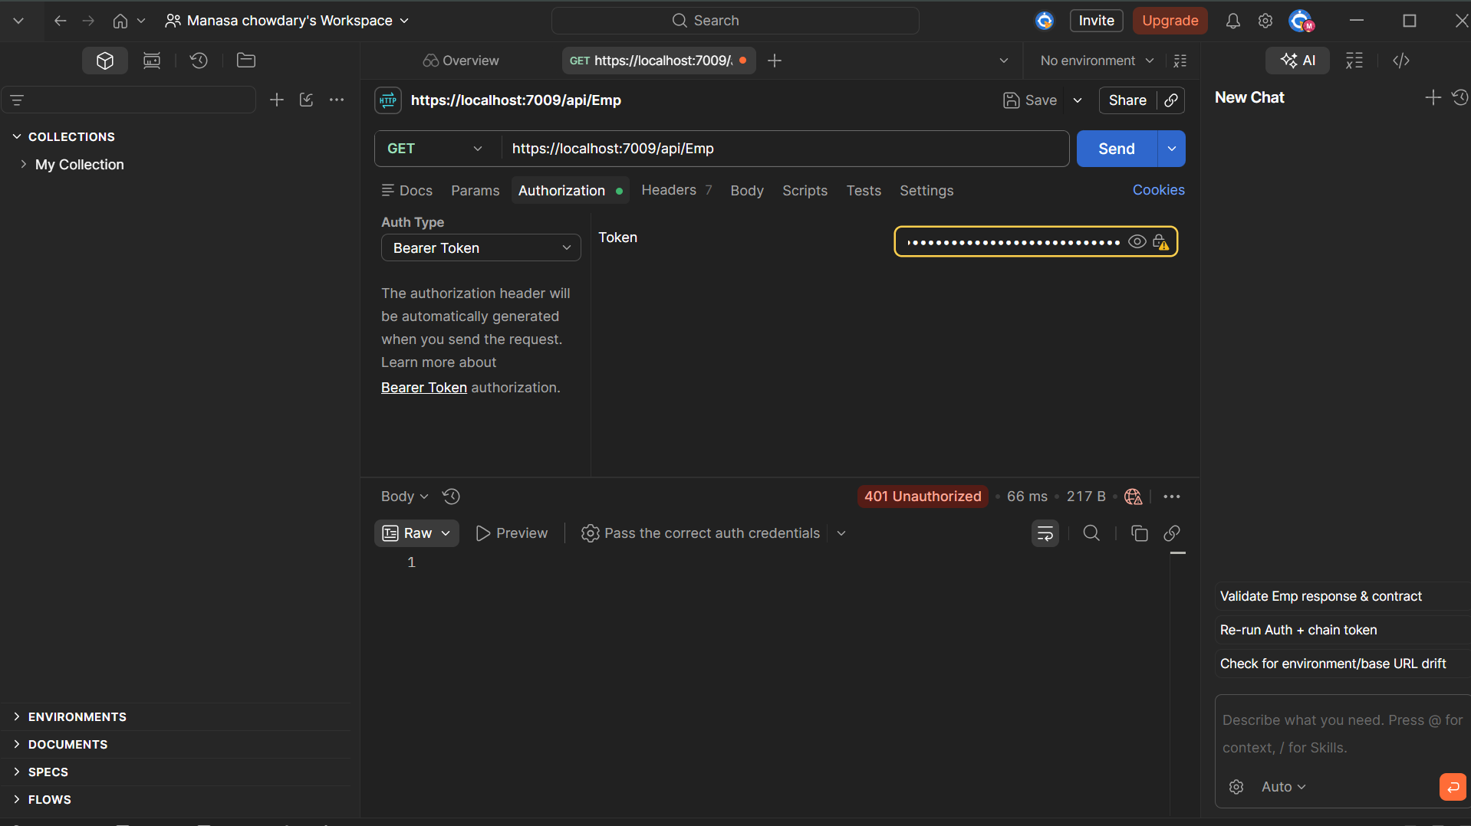

Figure 4: Expired JWT token returning 401 Unauthorized.

Figure 5: Request using an unauthorized POC role returning 401 Unauthorized.


Figure 6: Request using the authorized Admin role returning 200 OK.


7. Result
Successfully implemented JWT Bearer authentication and authorization in an ASP.NET Core Web API. JWT tokens were generated with issuer, audience, claims, roles, and expiration. Protected API endpoints were successfully tested using Postman. Requests without valid tokens, modified tokens, expired tokens, and unauthorized roles were rejected, while valid authenticated users with the required role were successfully authorized.

